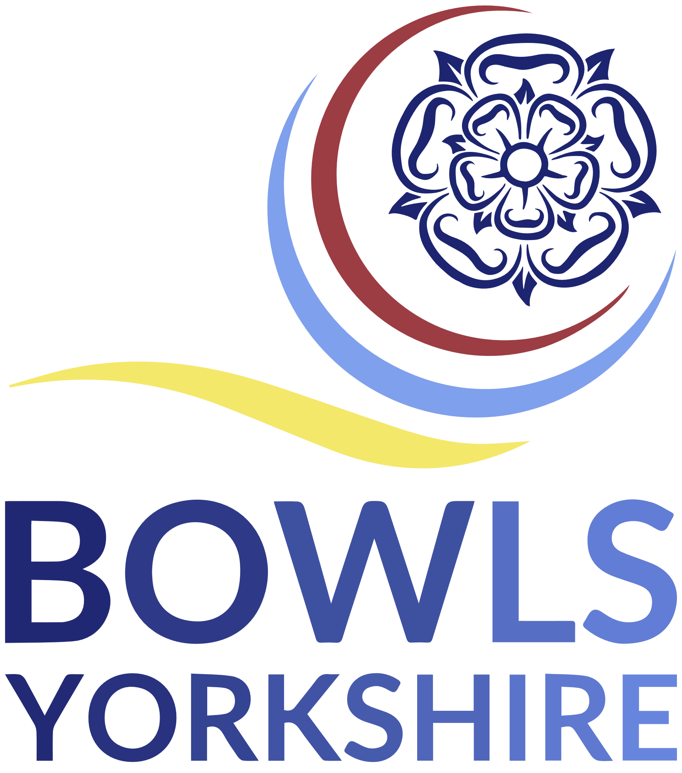
Support Officer, Bowls Yorkshire
Tenure: 1 Year - This is a voluntary position.
Role Summary
At the heart of Bowls Yorkshire’s purpose is encouraging people to participate in the sport of bowls. This activity includes retaining those within the sport as well as seeing more people discovering the joy of bowls. This post will play a key role in achieving those objectives.

Responsibilities
- Develop a coaching system that can support development at all levels
- Ensure a safeguarding provision and culture which allows people to participate safely
- Develop positive relationships and partnerships with key bowling bodies, funding bodies and development organisations
- Engage with non-affiliated clubs through collective events
- Improve communication
- Move Bowls Yorkshire towards being a formal non-profit organisation/charity
General Requirements
- Know and understand Bowls Yorkshire aims and objectives
- Play a positive role in the strategic and organisational development of Bowls Yorkshire
- Serve as an active advocate and ambassador for Bowls Yorkshire
- Prepare for, attend, and conscientiously participate in Board meetings
- Participate as required in Committees or working groups
- Work cooperatively and liaise with other Board members
- Respect the views and opinions of all other Board members and any others who attend Board meetings, and of any Focus groups or Club members more widely
- Play a part in assessing the performance of Bowls Yorkshire against its aims
- Follow Bowls Yorkshire and Bowls England rules and regulations and Board resolutions
- Disclose any potential conflicts of interest before meetings and actual conflicts during meetings
- Maintain confidentiality as appropriate, when dealing with or discussing issues of a personal or Club nature
1 | P a g e

